Feature image: See Why Classic Lashes Are a Must in Houston!

Title:Top Benefits of Getting Classic Lash Extensions in Houston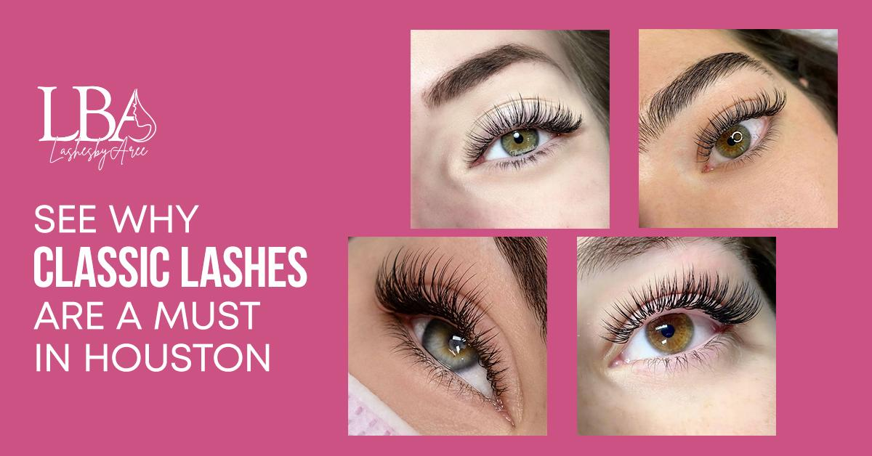
Focus Keyword: Classic Lash Extensions in Houston
Secondary Keyword:
before and after classic lash extensions
natural classic lash extensions
Classic lash fill
Classic lash look
Natural eyelash extensions

Internal link:
Best Eyelash Extensions In houston Tx: https://lashesbyaree.com/

Meta Description:
Learn why Lashes by Aree offers the best Classic Lash Extensions in Houston! Save time, boost confidence & enjoy natural glamour. Book now!

Top Benefits of Getting Classic Lash Extensions in Houston H1
If having perfectly polished lashes in the morning excites you, you’re in the right place. At our salon in Houston for natural classic lash extensions, we focus on bringing out the best in our clients without changing their whole look. For Houstonians who like class, time efficiency and being confident, our Classic Lash Extensions in Houston are much more than just a passing trend. Why is this service making such a significant difference in our approach to beauty routines? Let’s explore.

1. Achieve a Naturally Stunning Look H2
Soft, natural-looking results are what make classic lash extensions so famous in Houston. Unlike drama-focused looks, classic eyelash styles don’t overdo it. They only use one extension per natural lash for a light and gentle effect. The result? Natural-looking lashes that simply look better and fuller, just the way you’re meant to be seen by those who love you.
You won’t notice lumps in your mascara or blurry eyeliner when using classic eyelash. However, all you’ll see in your mirror are your own, natural-looking eyelashes that shape your eyes. You’ll find this style looks at home when you go out on a board meeting or a weekend brunch, without anyone noticing.

2. Save Time (and Sanity) Every Morning H2
With everyone in Houston always on the go, we give our clients the option to benefit from our quick lash extensions. If you had 15–20 minutes less to get ready, mornings would be much better. Maybe you don’t need to worry about your eyelash curler sticking or adding another layer of mascara after being caught in the rain when you have classic eyelashes. Classic lashes mean you can be ready every hour of the day and night.
Our clients really appreciate the idea of not wearing makeup if they don’t want to. Just as one of our clients said, “I look good when I wake up”. For a Houston-based entrepreneur, it feels just like magic! Classic and Natural eyelash extensions are also good for Houston’s climate, as they resist sweating and help you keep your makeup intact all day long.

3. Built to Last in Houston’s Climate H2
Traditional makeup tends to melt on our faces as the weather around here gets sticky. Classic lash extensions are made to last a long time. Since they feature medical-grade adhesive and are made of high-quality synthetic fibers, they hold their form any day, even if it’s hot outside.
You won’t have to ‘touch up’ your makeup at lunch or worry about smeared mascara. Your lashes stay perfect, whether you’re at a Texans game or walking through the park.

4. Customized to Your Unique Beauty H2
We don’t think beauty should be limited to a certain size or style here at Lashes by Aree. Your consultation allows our artists to look at your eyes, count your lashes and learn about your style before deciding on a natural classic lash extensions look. Decide between thin, highly defined, or lifted highlights, each designed to enhance your face.
If you want a cat-eye effect, almond-shaped eyes are perfect, but round eyes shine when their lengths are matched everywhere. “I was surprised my lashes could make my eyes look that big and bright,” one of our customers observed.

5. Gentle on Natural Lashes H3
Afraid something could get broken? Incorrect use aside, correctly applied classic lash extensions, in fact, help to protect and strengthen your natural lash line. They apply hand-selected, thin eyelash extensions to your natural lashes so they remain healthy.
Get a classic lash fill once or twice within 2–3 weeks to update your look without causing any issues for your lashes. It’s basically a routine to keep your eyes healthy!

6. Hypoallergenic & Safe for Sensitive Eyes H3
At Lashes by Aree, you can feel relaxed without worry. Natural classic lash extensions are made from hypoallergenic adhesives and medical materials to be kind to all eye types. Using regular mascara or weak eyelash products may bring irritation, but our products make sure your skin is safe.
Many Houstonians with allergies or sensitivities choose our salon because of its strong safety measures. Wear lashes that are beautiful and safe for your eyes, because being pretty shouldn’t mean being uncomfortable.

7. Effortless Maintenance with Classic Lash Fills H3
Keep your eyelashes looking great without the work. Make sure to schedule the lash fill service every 2–3 weeks to maintain your natural symmetry over time. Your artist will replace the lashes you’ve lost and link new ones with your existing set, all in around 60–90 minutes.
Applying it this way means you need less time and less money than with a new full application. You can also opt for mobile beauty professionals who can come by to deliver the same beauty, without disrupting your busy routines.

8. Accentuate Your Natural Eye Color H3
Classic lash extensions aren’t only for length; they also help strengthen what’s already on your eyelashes. Applying featherlight extensions near your eyebrows, we bring out the best in any eye color, giving hazel a warmer look, making blues more intense and making brown eyes glow richer.
You can skip the bright eyeshadow and fake eyes. By wearing a classic lash look, you naturally draw attention to your eyes and fascinate the people you see.

Before and After Classic Lash Extensions: Real Transformations H2
The results people get from before and after lash extensions show how amazing they are. Many clients start with meagre, straight eyelashes and finish with shiny and awake-looking eyes. At first, Sarah in Houston would hide behind her glasses. With the help of lashing, “I feel good about myself in ways I didn’t think possible!”
Eyelashes are not only about the body, but also about emotions. According to one of our customers, “It’s really about taking care of you.”

The Lashes by Aree Difference: Why We’re the Best H2
What sets us apart as the best eyelash extensions in Houston TX?
- Licensed Technicians: Each of our expert technicians completes special training in both style and safety.
- Premium Products: We offer premium extensions and adhesives made from silk and hypoallergenic materials that won’t hurt your scalp.
- Luxurious Experience: Our salon is equipped with a spa atmosphere, relaxing music and you will receive a treat of a complimentary drink.
- Glamorous, Yet Affordable: Good pricing and membership plans let luxury come to even your closet.

How It Works: Your Journey to Perfect Lashes H3
- Consultation: Let us know what you want and we’ll help you create your favorite classic lash style.
- Application: Go to sleep as we calmly place the extensions with our hands, ensuring it’s a happy hour for you.
- Aftercare: We’ll advise you to stay away from oil products, brush your lashes daily and make sure you get classic fillings at the recommended times.

Join the Lash Revolution H3
Because Houston is such a dynamic city, why choose something average? With Classic Lash Extensions in Houston, you gain confidence, convenience and care alongside their beautiful results. We’re happy to be part of what makes your day special at Lashes by Aree.
Are you ready to change the way you dress? Call now and try the superior eyelash extensions in Houston TX. Reaching your dream lashes is quicker than ever with just a click.

GMB
Wanting to enjoy luscious eyelashes that stick around? Our focus at Lashes by Aree is to add gorgeous Classic Lash Extensions that are customized for your style and weigh almost nothing. Sensitive-eye friendly and medical grade, our lashes offer a natural classic look and resist Houston’s humidity. Reduce your morning time, get great results and make your eyes the standout feature with no mascara. What makes Lashes by Aree different from others? Gifted artists who have mastered the exact techniques used in painting. Robust and premium parts to ensure a perfect look. Makeup and eyeliner tailored to fit your eye color and look. Quick classic lash fill-up every 2 to 3 weeks and you’re good to go! Our lashes are ideal for people always on the run, getting married or those seeking a confidence boost, they are carefree, secure and always elegant. View photos of before and after classic lash extensions to learn what makes us the leading choice in Houston, TX. Interested in celebrating your best and brightest self? It’s easy to book your appointment now at Lashes by Aree for lashes that are as special as you are.

